|  |  |
| --- | --- |
| Last updated: | August 2024 |

**JOB DESCRIPTION**

|  |  |  |  |
| --- | --- | --- | --- |
| Post title: | **Senior Administrative Assistant** | | |
| Standard Occupation Code: (UKVI SOC CODE) |  | | |
| School/Department: | Student and Education Services (SAAA) | | |
| Faculty: | Student Experience Directorate (SED) | | |
| Career Pathway: | Management, Specialist and Administrative (MSA) | Level: | 3 |
| Posts responsible to: | Exams and Awards Team, Team Leader (MSA 4) | | |
| Posts responsible for: | Up to 3 administrators (L2b)  Supervision of up to 160 casual staff at peak times | | |
| Post base: | Office-based | | |

|  |
| --- |
| Job purpose |
| To ensure the provision of comprehensive, effective and efficient administrative support to enable the seamless delivery of exams-, awards- or graduation-related activities.  To provide detailed, specialist advice and guidance as required.  To support agreements with internal and external providers to ensure relevant services are delivered within budget and timescales. |

| Key accountabilities/primary responsibilities | | % Time |
| --- | --- | --- |
|  | To lead on delegated responsibilities (see Appendix 2), ensuring services, venues and casual staff are available at the appropriate time. | 20% |
|  | To oversee administrative support processes, supervising the work of clerical/administrative assistants, to ensure work is completed, in an accurate and timely manner. | 17.5% |
|  | To review procedures and processes, ensuring they are fit for purpose and maximise efficiency, making recommendations for improvements where identified and implementing agreed change. | 17.5% |
|  | To oversee team members’ output, monitoring service, quality and performance towards set objectives, and identifying and providing training, coaching and mentoring as required | 20% |
|  | To provide detailed advice and guidance on specialist defined processes and procedures to internal and external customers, using judgement to suggest the most appropriate course of action where appropriate. | 5% |
|  | To work with team leader to provide effective recruitment for permanent, fixed term contract, temporary and casual staff; support training and performance monitoring for temporary and casual staff as required. | 5% |
| 7 | Contribute, as a member of Student and Education Services, towards broader initiatives to ensure and implement an excellent student experience. Participate in cross-functional activities such as international student registration, open days and student recruitment events, confirmation and clearing. | 5% |
| 8. | To work collaboratively within Student and Education Services and in other professional services departments to ensure shared responsibilities are agreed and met in a timely manner so that student-facing processes are delivered seamlessly. | 5% |
| 9. | Any other duties as allocated by the line manager following consultation with the post holder. | 5% |

| Internal and external relationships |
| --- |
| Other members of the department/University staff.  External customers  Casual staff and volunteers from other teams during peak periods |

| Special requirements |
| --- |
| Demonstrate Southampton University behaviours (Embedding Collegiality – see Appendix 1). |

**PERSON SPECIFICATION**

|  |  |  |  |
| --- | --- | --- | --- |
| Criteria | Essential | Desirable | How to be assessed |
| Qualifications, knowledge and experience | Skill level equivalent to achievement of HNC, A-Level, NVQ3 with proven work experience acquired in relevant roles and job-related training.  Able to accurately analyse and interpret complex quantitative and qualitative data, presenting summary information in a clear and concise format.  Good knowledge of MS Office applications. | Advanced skills in Microsoft Office applications.  Able to apply a comprehensive understanding of relevant University systems and procedures and procedures, and an awareness of activities in the broader work area. | Application and Interview |
| Planning and organising | Able to plan and prioritise a range of one’s own, and the team’s, activities, working within the team’s general activity plan.  Able to successfully plan and deliver activities over a period of several months.(e.g. to co-ordinate an event) | Experience of organising large-scale events | Application and Interview |
| Problem solving and initiative | Able to identify and solve problems by applying judgement and initiative to tackle some situations in new ways and by developing improved work methods.  Able to apply an understanding of relevant systems and procedures, and an awareness of activities in the broader work area.  Analyse changes to systems and processes to understand implications, and to cascade this information. |  |  |
| Management and teamwork | Able to solicit ideas and opinions to drive continual improvements.  Able to positively influence the way a team works together by acting as a role model and identifying individuals’ strengths and weaknesses.  Able to ensure staff are clear about changing work priorities and service expectations.  Able to effectively allocate to, and check work of staff, coaching/ training and motivating staff as required. | Supervisory experience  Recruitment experience | Application and Interview |
| Communicating and influencing | Able to elicit information to identify specific customer needs.  Able to offer proactive advice and guidance. | Presentation skills or experience of presenting to large groups (>50) | Interview |
| Other skills and behaviours | Able to demonstrate values and behaviours associated with excellent customer service. |  | Application |
| Special requirements | Leave is granted only in exceptional circumstances during peak times (which are usually but not exclusively December, January, May and July) |  | Interview |

**JOB HAZARD ANALYSIS**

**Is this an office-based post?**

|  |  |
| --- | --- |
| Yes | If this post is an office-based job with routine office hazards (eg: use of VDU), no further information needs to be supplied. Do not complete the section below. |
| No | If this post is not office-based or has some hazards other than routine office (eg: more than use of VDU) please complete the analysis below.  Hiring managers are asked to complete this section as accurately as possible to ensure the safety of the post-holder. |

## - HR will send a full PEHQ to all applicants for this position. Please note, if full health clearance is required for a role, this will apply to all individuals, including existing members of staff.

|  |  |  |  |
| --- | --- | --- | --- |
| **ENVIRONMENTAL EXPOSURES** | **Occasionally**  (<30% of time) | **Frequently**  (30-60% of time) | **Constantly**  (> 60% of time) |
| Outside work | X |  |  |
| Extremes of temperature (eg: fridge/ furnace) | X |  |  |
| ## Potential for exposure to body fluids |  |  |  |
| ## Noise (greater than 80 dba - 8 hrs twa) |  |  |  |
| ## Exposure to hazardous substances (eg: solvents, liquids, dust, fumes, biohazards). Specify below: |  |  |  |
| Frequent hand washing |  |  |  |
| Ionising radiation |  |  |  |
| **EQUIPMENT/TOOLS/MACHINES USED** | | | |
| ## Food handling |  |  |  |
| ## Driving university vehicles(eg: car/van/LGV/PCV) |  |  |  |
| ## Use of latex gloves (prohibited unless specific clinical necessity) |  |  |  |
| ## Vibrating tools (eg: strimmers, hammer drill, lawnmowers) |  |  |  |
| **PHYSICAL ABILITIES** | | | |
| Load manual handling | X |  |  |
| Repetitive crouching/kneeling/stooping |  |  |  |
| Repetitive pulling/pushing |  |  |  |
| Repetitive lifting |  |  |  |
| Standing for prolonged periods |  |  |  |
| Repetitive climbing (ie: steps, stools, ladders, stairs) |  |  |  |
| Fine motor grips (eg: pipetting) |  |  |  |
| Gross motor grips |  |  |  |
| Repetitive reaching below shoulder height | X |  |  |
| Repetitive reaching at shoulder height | X |  |  |
| Repetitive reaching above shoulder height |  |  |  |
| **PSYCHOSOCIAL ISSUES** | | | |
| Face to face contact with public | X |  |  |
| Lone working |  |  |  |
| ## Shift work/night work/on call duties |  |  |  |

Appendix 1. Embedding Collegiality

Collegiality represents one of the four core principles of the University; Collegiality, Quality, Internationalisation and Sustainability. Our Southampton Behaviours set out our expectations of all staff across the University to support the achievement of our strategy.

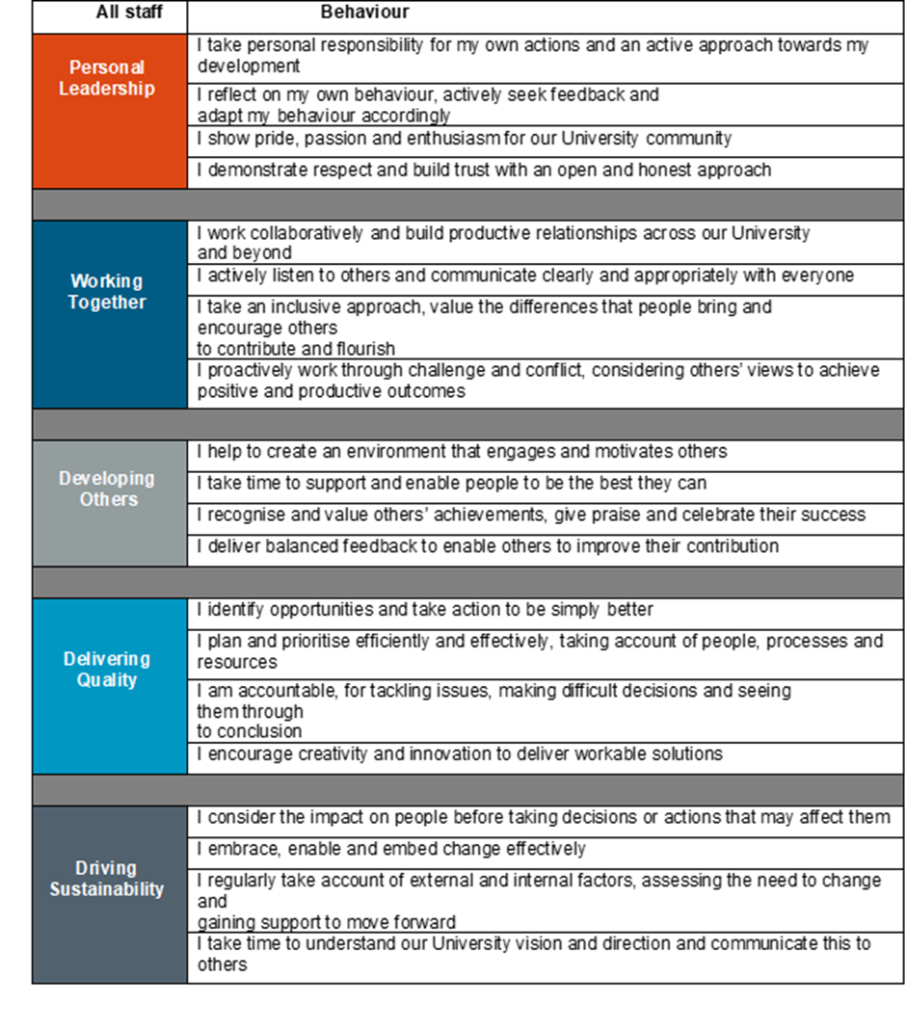

Appendix 2. Functional activities within the Exams, Awards and Graduation team

The Exams and Awards Team is responsible for a range of business processes that cover those stages in the student life cycle.

**1. Exams**

*To include*:*

* Setting up 3rd party scheduling software and liaising with other departments to manage interfaces
* Supervise data amendments which may influence exam timetable
* Supervise student seating
* Supervise invigilation recruitment, assessment, training, scheduling and payroll:
* Supervise scheduling for students with additional exam requirements
* Supervise receipt and production of exam papers, including those for off-campus exams
* Exam preparation including exam packs, liaison with other professional services or service providers to ensure venues are set up
* Mentoring staff in faculties in exam processes and systems
* Exam operation: to include training team members, problem solving, recording issues for reporting/finding long term solutions, support team leader in supervising invigilator attendance and performance.

1. **Awards and certification**

*To include*:*

* Award management including receipt of pass lists and preparation of University Memo
* Supervise maintenance of award archives
* Supervise printing and quality management of official degree certification
* Supervise distribution of official degree certification
* Manage products available on online store and supervise the completion of orders within published service timescales
* Mentoring staff in faculties in award-related processes and systems.

1. **Graduation**

*To include*:*

* Graduation ceremony scheduling and data management and maintenance

Certification handout

* These lists are not exhaustive; other activities may be included due to process or system change, and by arrangement with the manager/team leader